Code:

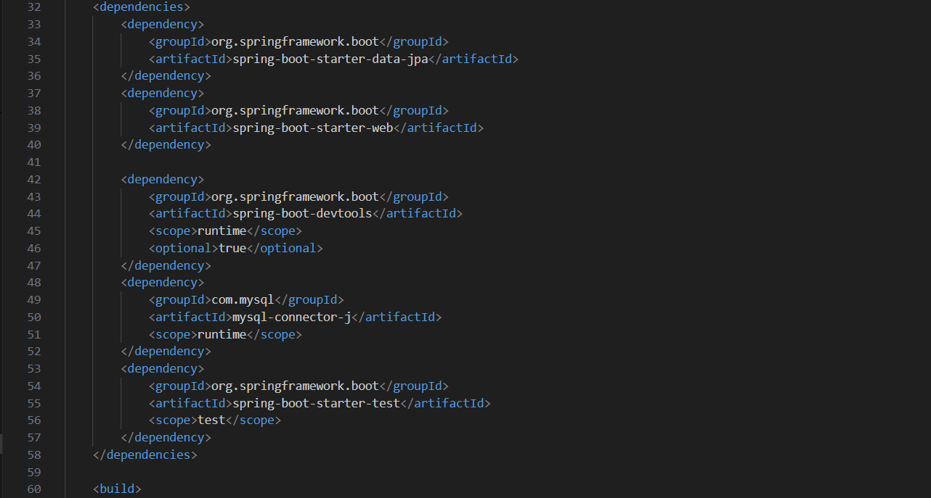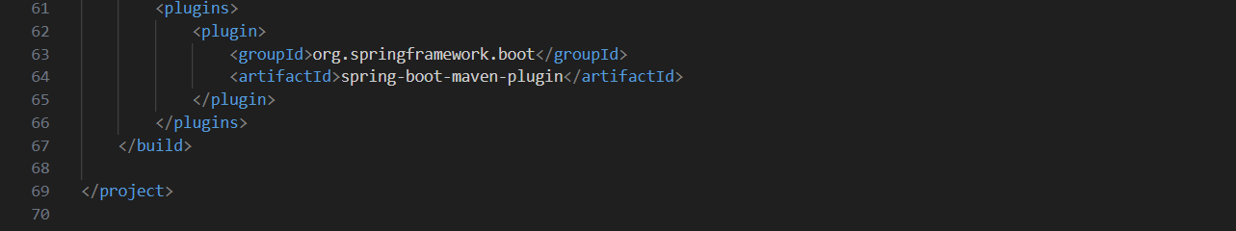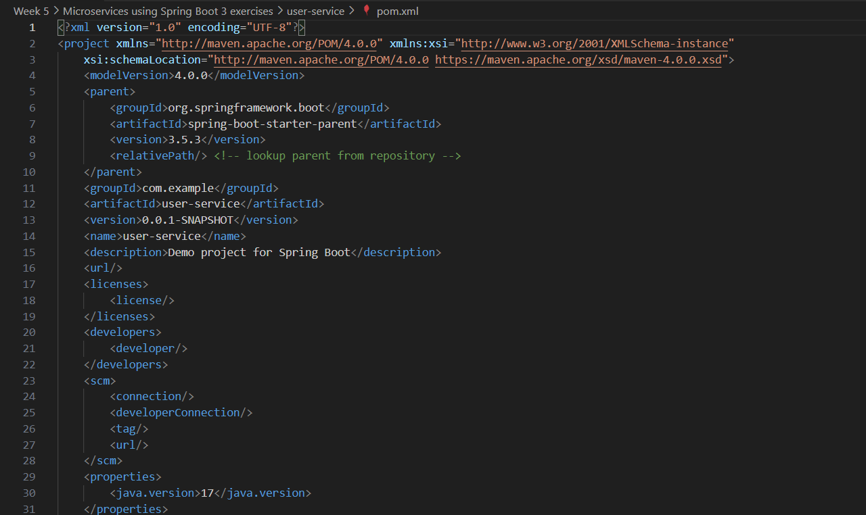pom.xml

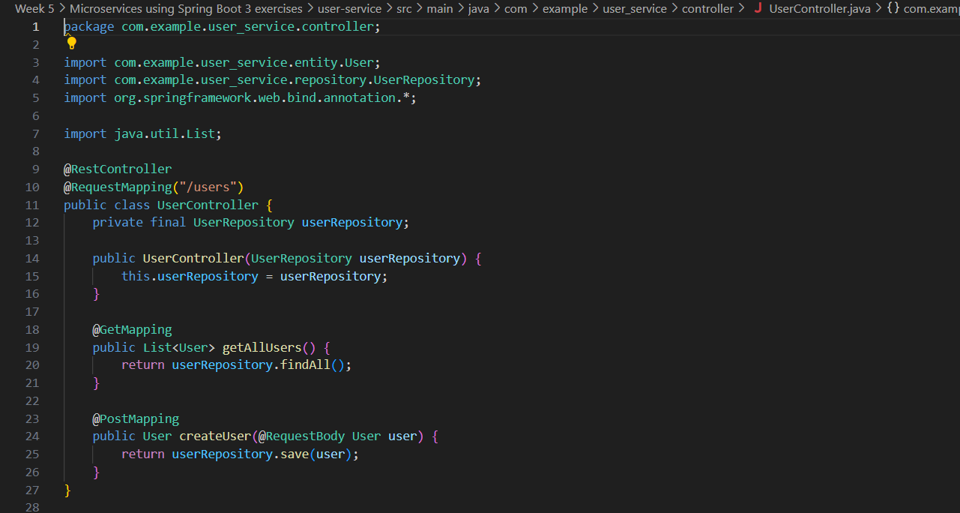UserController.java

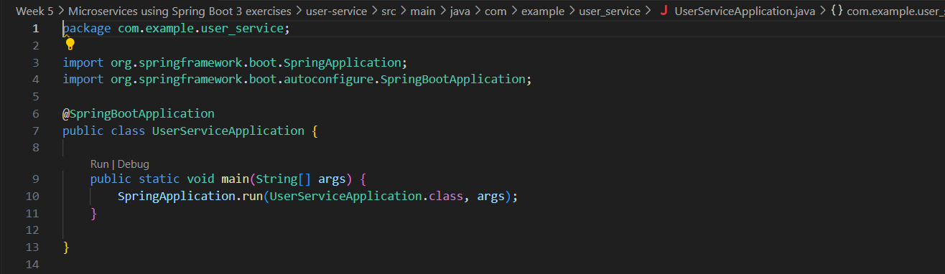UserServiceApplication.java

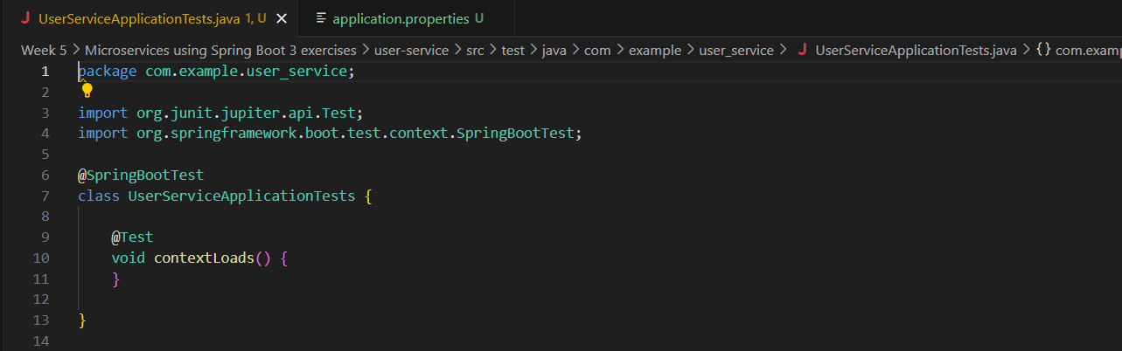UserServiceApplicationTests.java

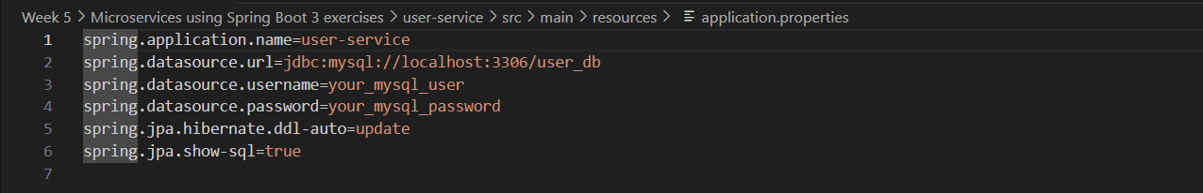application.properties

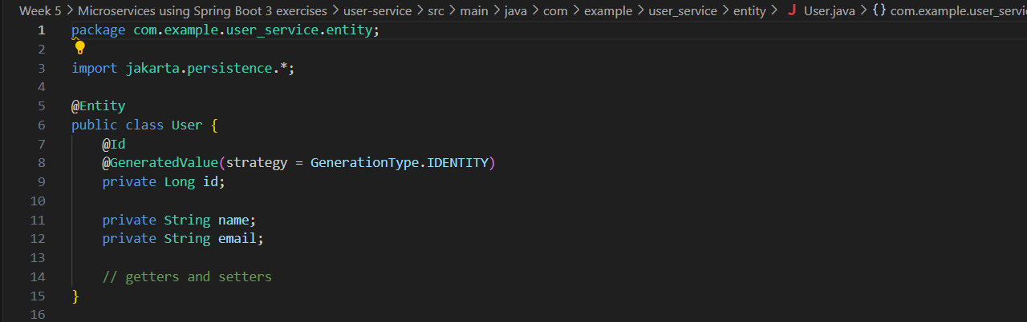User.java